**UNIT-1**

**Introduction to Artificial intelligence:** Definition of AI, Why AI? Difference between Symbolic and Non-symbolic Representation, Research Focuses of Artificial Intelligence History of AI: Turing Test, Chinese Room, Applications of AI: Natural Language Processing, Intelligent Retrieval from Databases, Expert Systems, Theorem Proving, Robotics, Combinatorial and Scheduling Problems, Perception Problems, Neural Architectures, Game Playing, Objectives of AI, Artificial Intelligence Programming, Criticism of AI, Future of AI.

**What is Artificial Intelligence?**

In today's world, technology is growing very fast, and we are getting in touch with different new technologies day by day.

Here, one of the booming technologies of computer science is Artificial Intelligence which is ready to create a new revolution in the world by making intelligent machines.The Artificial Intelligence is now all around us. It is currently working with a variety of subfields, ranging from general to specific, such as self-driving cars, playing chess, proving theorems, playing music, Painting, etc.

AI is one of the fascinating and universal fields of Computer science which has a great scope in future. AI holds a tendency to cause a machine to work as a human.

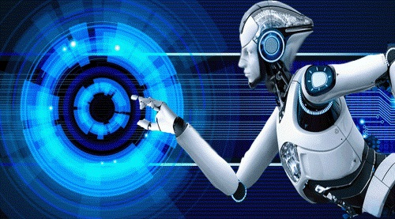

Artificial Intelligence is composed of two words **Artificial** and **Intelligence**, where Artificial defines *"man-made,"* and intelligence defines *"thinking power"*, hence AI means *"a man-made thinking power."*

So, we can define AI as:

 "It is a branch of computer science by which we can create intelligent machines which can behave like a human, think like humans, and able to make decisions."

Artificial Intelligence exists when a machine can have human based skills such as learning, reasoning, and solving problems

With Artificial Intelligence you do not need to preprogram a machine to do some work, despite that you can create a machine with programmed algorithms which can work with own intelligence, and that is the awesomeness of AI.

It is believed that AI is not a new technology, and some people says that as per Greek myth, there were Mechanical men in early days which can work and behave like humans.

**Why Artificial Intelligence?**

Before Learning about Artificial Intelligence, we should know that what is the importance of AI and why should we learn it. Following are some main reasons to learn about AI:

* With the help of AI, you can create such software or devices which can solve real-world problems very easily and with accuracy such as health issues, marketing, traffic issues, etc.
* With the help of AI, you can create your personal virtual Assistant, such as Cortana, Google Assistant, Siri, etc.
* With the help of AI, you can build such Robots which can work in an environment where survival of humans can be at risk.
* AI opens a path for other new technologies, new devices, and new Opportunities.

**Goals of Artificial Intelligence**

Following are the main goals of Artificial Intelligence:

1. Replicate human intelligence
2. Solve Knowledge-intensive tasks
3. An intelligent connection of perception and action
4. Building a machine which can perform tasks that requires human intelligence such as:
   * Proving a theorem
   * Playing chess
   * Plan some surgical operation
   * Driving a car in traffic
5. Creating some system which can exhibit intelligent behavior, learn new things by itself, demonstrate, explain, and can advise to its user.

**What Comprises to Artificial Intelligence?**

Artificial Intelligence is not just a part of computer science even it's so vast and requires lots of other factors which can contribute to it. To create the AI first we should know that how intelligence is composed, so the Intelligence is an intangible part of our brain which is a combination of **Reasoning, learning, problem-solving perception, language understanding, etc**.

To achieve the above factors for a machine or software Artificial Intelligence requires the following discipline:

* Mathematics
* Biology
* Psychology
* Sociology
* Computer Science
* Neurons Study
* Statistics

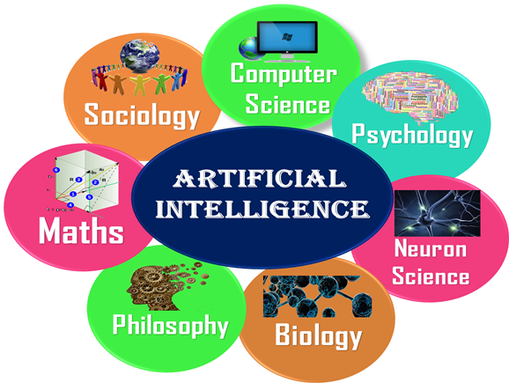

# **Types of Artificial Intelligence:**

Artificial Intelligence can be divided in various types, there are mainly two types of main categorization which are based on capabilities and based on functionally of AI. Following is flow diagram which explain the types of AI.

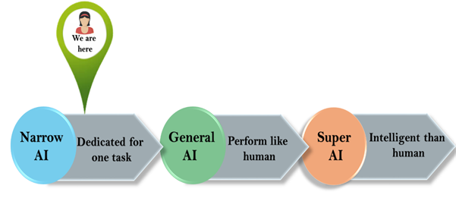

### **1. Weak AI or Narrow AI:**

* Narrow AI is a type of AI which is able to perform a dedicated task with intelligence. The most common and currently available AI is Narrow AI in the world of Artificial Intelligence.
* Narrow AI cannot perform beyond its field or limitations, as it is only trained for one specific task. Hence it is also termed as weak AI. Narrow AI can fail in unpredictable ways if it goes beyond its limits.
* Apple Siriis a good example of Narrow AI, but it operates with a limited pre-defined range of functions.
* IBM's Watson supercomputer also comes under Narrow AI, as it uses an Expert system approach combined with Machine learning and natural language processing.
* Some Examples of Narrow AI are playing chess, purchasing suggestions on e-commerce site, self-driving cars, speech recognition, and image recognition.

### **2. General AI:**

* General AI is a type of intelligence which could perform any intellectual task with efficiency like a human.
* The idea behind the general AI to make such a system which could be smarter and think like a human by its own.
* Currently, there is no such system exist which could come under general AI and can perform any task as perfect as a human.
* The worldwide researchers are now focused on developing machines with General AI.
* As systems with general AI are still under research, and it will take lots of efforts and time to develop such systems.

### **3. Super AI:**

* Super AI is a level of Intelligence of Systems at which machines could surpass human intelligence, and can perform any task better than human with cognitive properties. It is an outcome of general AI.
* Some key characteristics of strong AI include capability include the ability to think, to reason, solve the puzzle, make judgments, plan, learn, and communicate by its own.
* Super AI is still a hypothetical concept of Artificial Intelligence. Development of such systems in real is still world changing task.

**Advantages of Artificial Intelligence**

Following are some main advantages of Artificial Intelligence:

* **High Accuracy with less errors:** AI machines or systems are prone to less errors and high accuracy as it takes decisions as per pre-experience or information.
* **High-Speed:** AI systems can be of very high-speed and fast-decision making, because of that AI systems can beat a chess champion in the Chess game.
* **High reliability:** AI machines are highly reliable and can perform the same action multiple times with high accuracy.
* **Useful for risky areas:** AI machines can be helpful in situations such as defusing a bomb, exploring the ocean floor, where to employ a human can be risky.
* **Digital Assistant:** AI can be very useful to provide digital assistant to the users such as AI technology is currently used by various E-commerce websites to show the products as per customer requirement.
* **Useful as a public utility:** AI can be very useful for public utilities such as a self-driving car which can make our journey safer and hassle-free, facial recognition for security purpose, Natural language processing to communicate with the human in human-language, etc.

**Disadvantages of Artificial Intelligence**

Every technology has some disadvantages, and thesame goes for Artificial intelligence. Being so advantageous technology still, it has some disadvantages which we need to keep in our mind while creating an AI system. Following are the disadvantages of AI:

* **High Cost:** The hardware and software requirement of AI is very costly as it requires lots of maintenance to meet current world requirements.
* **Can't think out of the box:** Even we are making smarter machines with AI, but still they cannot work out of the box, as the robot will only do that work for which they are trained, or programmed.
* **No feelings and emotions:** AI machines can be an outstanding performer, but still it does not have the feeling so it cannot make any kind of emotional attachment with human, and may sometime be harmful for users if the proper care is not taken.
* **Increase dependency on machines:** With the increment of technology, people are getting more dependent on devices and hence they are losing their mental capabilities.
* **No Original Creativity:** As humans are so creative and can imagine some new ideas but still AI machines cannot beat this power of human intelligence and cannot be creative and imaginative.

**Prerequisite**

Before learning about Artificial Intelligence, you must have the fundamental knowledge of following so that you can understand the concepts easily:

* Any computer language such as C, C++, Java, Python, etc. (knowledge of Python will be an advantage)
* Knowledge of essential Mathematics such as derivatives, probability theory, etc.

**Application of AI**

Artificial Intelligence has various applications in today's society. It is becoming essential for today's time because it can solve complex problems with an efficient way in multiple industries, such as Healthcare, entertainment, finance, education, etc. AI is making our daily life more comfortable and fast.

Following are some sectors which have the application of Artificial Intelligence:

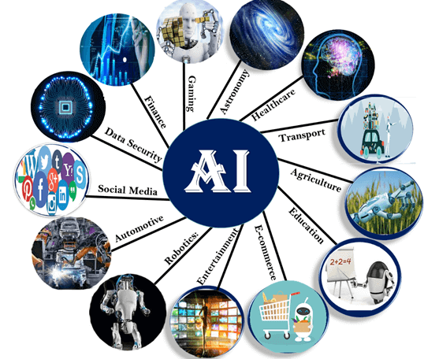

### **1. AI in Astronomy**

* Artificial Intelligence can be very useful to solve complex universe problems. AI technology can be helpful for understanding the universe such as how it works, origin, etc.

### **2. AI in Healthcare**

* In the last, five to ten years, AI becoming more advantageous for the healthcare industry and going to have a significant impact on this industry.
* Healthcare Industries are applying AI to make a better and faster diagnosis than humans. AI can help doctors with diagnoses and can inform when patients are worsening so that medical help can reach to the patient before hospitalization.

### **3. AI in Gaming**

* AI can be used for gaming purpose. The AI machines can play strategic games like chess, where the machine needs to think of a large number of possible places.

### **4. AI in Finance**

* AI and finance industries are the best matches for each other. The finance industry is implementing automation, chatbot, adaptive intelligence, algorithm trading, and machine learning into financial processes.

### **5. AI in Data Security**

* The security of data is crucial for every company and cyber-attacks are growing very rapidly in the digital world. AI can be used to make your data more safe and secure. Some examples such as AEG bot, AI2 Platform, are used to determine software bug and cyber-attacks in a better way.

### **6. AI in Social Media**

* Social Media sites such as Facebook, Twitter, and Snapchat contain billions of user profiles, which need to be stored and managed in a very efficient way. AI can organize and manage massive amounts of data. AI can analyze lots of data to identify the latest trends, hashtag, and requirement of different users.

### **7. AI in Travel & Transport**

* AI is becoming highly demanding for travel industries. AI is capable of doing various travel related works such as from making travel arrangement to suggesting the hotels, flights, and best routes to the customers. Travel industries are using AI-powered chatbots which can make human-like interaction with customers for better and fast response.

### **8. AI in Automotive Industry**

* Some Automotive industries are using AI to provide virtual assistant to their user for better performance. Such as Tesla has introduced TeslaBot, an intelligent virtual assistant.
* Various Industries are currently working for developing self-driven cars which can make your journey more safe and secure.

### **9. AI in Robotics:**

* Artificial Intelligence has a remarkable role in Robotics. Usually, general robots are programmed such that they can perform some repetitive task, but with the help of AI, we can create intelligent robots which can perform tasks with their own experiences without pre-programmed.
* Humaid Robots are best examples for AI in robotics, recently the intelligent Humanoid robot named as Erica and Sophia has been developed which can talk and behave like humans.

### **10. AI in Entertainment**

* We are currently using some AI based applications in our daily life with some entertainment services such as Netflix or Amazon. With the help of ML/AI algorithms, these services show the recommendations for programs or shows.

### **11. AI in Agriculture**

* Agriculture is an area which requires various resources, labor, money, and time for best result. Now a day's agriculture is becoming digital, and AI is emerging in this field. Agriculture is applying AI as agriculture robotics, solid and crop monitoring, predictive analysis. AI in agriculture can be very helpful for farmers.

### **12. AI in E-commerce**

* AI is providing a competitive edge to the e-commerce industry, and it is becoming more demanding in the e-commerce business. AI is helping shoppers to discover associated products with recommended size, color, or even brand.

### **13. AI in education:**

* AI can automate grading so that the tutor can have more time to teach. AI chatbot can communicate with students as a teaching assistant.
* AI in the future can be work as a personal virtual tutor for students, which will be
* accessible easily at any time and any place.

**Symbolic AI**

* Symbolic AI refers to the fact that all steps are based on symbolic human readable representations of the problem that use logic and search to solve problem.
* Key advantage of Symbolic AI is that the reasoning process can be easily understood – a Symbolic AI program can easily explain why a certain conclusion is reached and what the reasoning steps had been.
* A key disadvantage of Symbolic AI is that for learning process – the rules and knowledge has to be hand coded which is a hard problem.

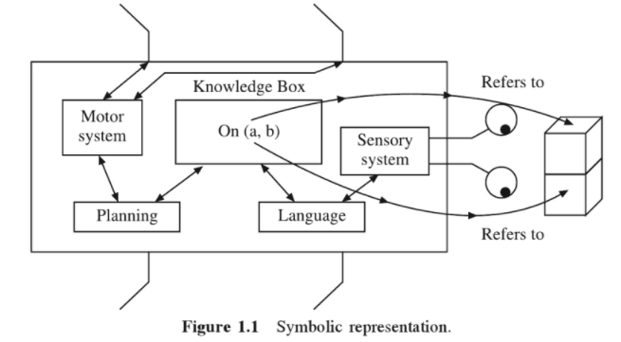

**Non-symbolic AI**

Non-symbolic AI systems do not manipulate a symbolic representation to find solutions to problems. Instead, they perform calculations according to some principles that have demonstrated to be able to solve problems.

* Examples of Non-symbolic AI include genetic algorithms, neural networks and deep learning.
* The origins of non-symbolic AI come from the attempt to mimic a human brain and its complex network of interconnected neurons.
* Non-symbolic AI is applied to critical applications such as self-driving cars, medical diagnosis among others.

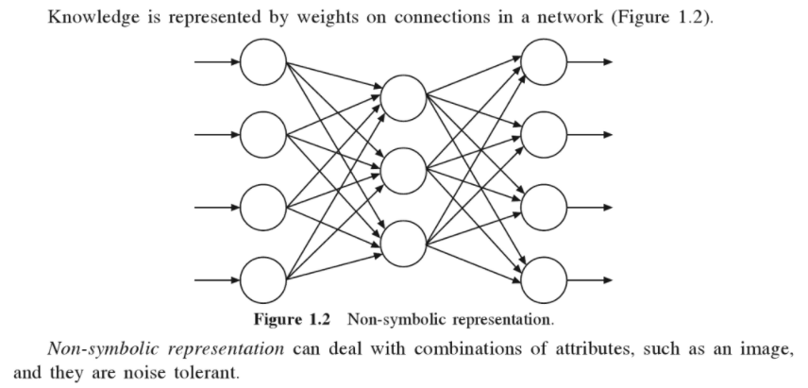

**Research Focus areas of Artificial Intelligence**

* **Large scale Machine Learning**: Machine Learning (ML) is concerned about developing systems that improve their performance with experience.
* **Deep Learning**: A subset of ML, Deep Learning (DL) is re-branding of neural networks- a class of models inspired by biological neurons in our brain.
* **Reinforcement Learning**: Reinforcement Learning (RL) is the closed form of learning to the way a human being learns.
* **Robotics:** Robotics is a separate branch of its own but it do has some overlap with AI. AI has made robot navigation in dynamic environment possible.
* **Computer Vision:** Computer vision (CV) is concerned with how the computer visually perceive the world around it.
* **Natural Language Processing:** Natural Language Processing (NLP) is concerned with systems that are able to perceive and understand spoken human language.
* **Internet of Things:** Internet of Things (IoT) is a concept that daily use physical devices are connected to the internet and can communicate with each other via exchange of data.
* **Neuromorphic Computing:** With rise of Deep Learning that relies on neurons based models, researchers have been developing hardware chips that can directly implement neural network architecture. These chips are designed to mimic the brain at the hardware level.

# **History of Artificial Intelligence**

Artificial Intelligence is not a new word and not a new technology for researchers. This technology is much older than you would imagine. Even there are the myths of Mechanical men in Ancient Greek and Egyptian Myths. Following are some milestones in the history of AI which defines the journey from the AI generation to till date development.

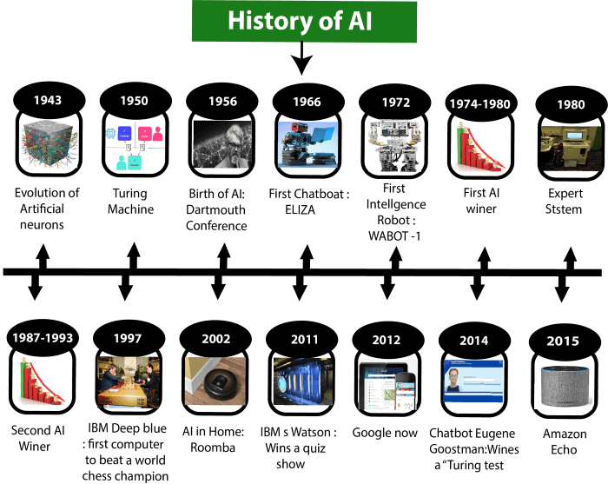

# **Turing Test in AI**

In 1950, Alan Turing introduced a test to check whether a machine can think like a human or not, this test is known as the Turing Test. In this test, Turing proposed that the computer can be said to be an intelligent if it can mimic human response under specific conditions.

Turing Test was introduced by Turing in his 1950 paper, "Computing Machinery and Intelligence," which considered the question, "Can Machine think?"

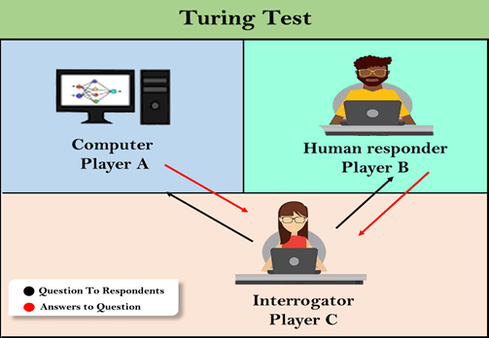

The Turing test is based on a party game "Imitation game," with some modifications. This game involves three players in which one player is Computer, another player is human responder, and the third player is a human Interrogator, who is isolated from other two players and his job is to find that which player is machine among two of them.

Consider, Player A is a computer, Player B is human, and Player C is an interrogator. Interrogator is aware that one of them is machine, but he needs to identify this on the basis of questions and their responses. The conversation between all players is via keyboard and screen so the result would not depend on the machine's ability to convert words as speech.

The test result does not depend on each correct answer, but only how closely its responses like a human answer. The computer is permitted to do everything possible to force a wrong identification by the interrogator.

The questions and answers can be like:

**Interrogator:** Are you a computer?

**PlayerA (Computer):** No

**Interrogator:** Multiply two large numbers such as (256896489*456725896)

**Player A:** Long pause and give the wrong answer.

In this game, if an interrogator would not be able to identify which is a machine and which is human, then the computer passes the test successfully, and the machine is said to be intelligent and can think like a human.

"In 1991, the New York businessman Hugh Loebner announces the prize competition, offering a $100,000 prize for the first computer to pass the Turing test. However, no AI program to till date, come close to passing an undiluted Turing test".

## The Chinese Room Argument:

There were many philosophers who really disagreed with the complete concept of Artificial Intelligence. The most famous argument in this list was "**Chinese Room**."

In the year **1980, John Searle** presented "**Chinese Room**" thought experiment, in his paper "**Mind, Brains, and Program**," which was against the validity of Turing's Test. According to his argument, "**Programming a computer may make it to understand a language, but it will not produce a real understanding of language or consciousness in a computer."**

**Features required for a machine to pass the Turing test:**

* **Natural language processing:** NLP is required to communicate with Interrogator in general human language like English.
* **Knowledge representation:** To store and retrieve information during the test.
* **Automated reasoning:** To use the previously stored information for answering the questions.
* **Machine learning:** To adapt new changes and can detect generalized patterns.
* **Vision (For total Turing test):** To recognize the interrogator actions and other objects during a test.
* **Motor Control (For total Turing test):** To act upon objects if requested.

**Applications of AI**

**Natural Language Processing:**

* Natural language processing is a subfield of linguistics, computer science, and artificial intelligence concerned with the interactions between computers and human language, in particular how to program computers to process and analyze large amounts of natural language data.
* Natural language processing tools can help businesses analyze data and discover insights, automate time-consuming processes, and help them gain a competitive advantage.
* The most interesting applications of natural language processing  in business:

[1.Sentiment Analysis](https://monkeylearn.com/blog/natural-language-processing-applications/)

[2.Text Classification](https://monkeylearn.com/blog/natural-language-processing-applications/)

[3.Chatbots & Virtual Assistants](https://monkeylearn.com/blog/natural-language-processing-applications/)

[4.Text Extraction](https://monkeylearn.com/blog/natural-language-processing-applications/)

[5.Machine Translation](https://monkeylearn.com/blog/natural-language-processing-applications/)

[6.Text Summarization](https://monkeylearn.com/blog/natural-language-processing-applications/)

[7.Market Intelligence](https://monkeylearn.com/blog/natural-language-processing-applications/)

[8.Auto-Correct](https://monkeylearn.com/blog/natural-language-processing-applications/)

[9.Intent Classification](https://monkeylearn.com/blog/natural-language-processing-applications/)

[10.Urgency Detection](https://monkeylearn.com/blog/natural-language-processing-applications/)

[11.Speech Recognition](https://monkeylearn.com/blog/natural-language-processing-applications/)

**Intelligent Retrieval from Databases:**

* Intelligent retrieval from databases is the application of artificial intelligence techniques to the task of efficient retrieval of information from very large databases. Using such techniques, significant increase in efficiency can be obtained.
* Some of these improvements are not available through standard methods of database query optimization.

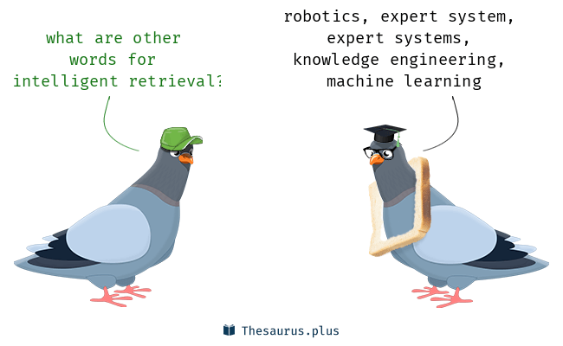

**Expert Systems:**

* An expert system is a computer program that is designed to solve complex problems and to provide decision-making ability like a human expert.
* It performs this by extracting knowledge from its knowledge base using the reasoning and inference rules according to the user queries.
* One of the common examples of an ES is a suggestion of spelling errors while typing in the Google search box.

**Block diagram that represents the working of an expert system:**

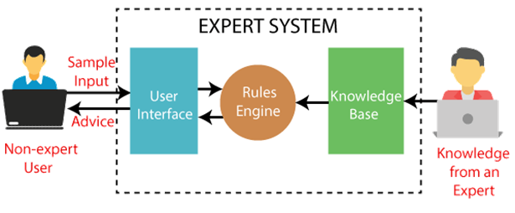

**Components of Expert System**

An expert system mainly consists of three components:

* **User Interface**
* **Inference Engine**
* **Knowledge Base**

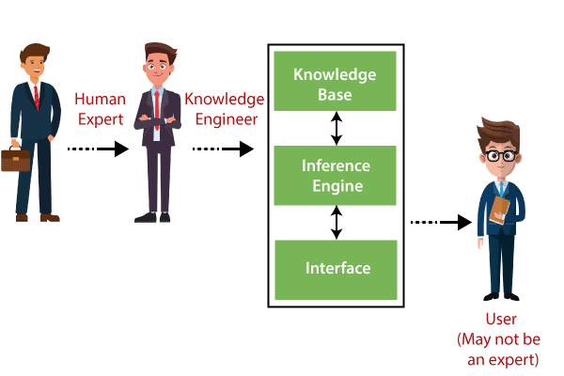

**1. User Interface**

* With the help of a user interface, the expert system interacts with the user, takes queries as an input in a readable format, and passes it to the inference engine. After getting the response from the inference engine, it displays the output to the user. In other words, it is an interface that helps a non-expert user to communicate with the expert system to find a solution.

**2. Inference Engine(Rules of Engine)**

* The inference engine is known as the brain of the expert system as it is the main processing unit of the system. It applies inference rules to the knowledge base to derive a conclusion or deduce new information. It helps in deriving an error-free solution of queries asked by the user.
* With the help of an inference engine, the system extracts the knowledge from the knowledge base.

**There are two types of inference engine:**

* **Deterministic Inference engine:** The conclusions drawn from this type of inference engine are assumed to be true. It is based on **facts** and **rules**.
* **Probabilistic Inference engine:** This type of inference engine contains uncertainty in conclusions, and based on the probability.
* **Inference engine uses the below modes to derive the solutions:**
* **Forward Chaining:** It starts from the known facts and rules, and applies the inference rules to add their conclusion to the known facts.
* **Backward Chaining:** It is a backward reasoning method that starts from the goal and works backward to prove the known facts.

**3. Knowledge Base**

* The knowledgebase is a type of storage that stores knowledge acquired from the different experts of the particular domain. It is considered as big storage of knowledge. The more the knowledge base, the more precise will be the Expert System.
* It is similar to a database that contains information and rules of a particular domain or subject.
* One can also view the knowledge base as collections of objects and their attributes. Such as a Lion is an object and its attributes are it is a mammal, it is not a domestic animal, etc.

**Components of Knowledge Base**

* **Factual Knowledge:** The knowledge which is based on facts and accepted by knowledge engineers comes under factual knowledge.
* **Heuristic Knowledge:** This knowledge is based on practice, the ability to guess, evaluation, and experiences.

**Theorem Proving**

Finding proof of a mathematical theorem requires following intelligence:

* 1.Requires the ability to make deductions from hypothesis.
* 2.It demands intuitive scales such as guessing which path should be proved first in order to help proving the algorithm.
* 3.It also requires judgments to guess accurately about which previously proven algorithms in subject area will be useful in the present proof.
* 4.Also sometimes it is needed to break the main problem to sub- problems to work on independently.
* Proving theorems is considered to require high intelligence
* If knowledge is represented by logic, theorem proving is reasoning.
* A new and remarkable development here is that several researchers at Google’s research center have developed an [**AI theorem-proving program**](https://arxiv.org/pdf/1904.03241.pdf).
* **Google AI system proves over 1200 mathematical theorems**
* Most of these theorems were in the area of linear algebra, real analysis and complex analysis.
* Mathematicians are already envisioning how this software can be used in day-to-day research

**Combinatorial and Scheduling Problems**

* Combinatorial and Scheduling Problems involve finding a grouping, ordering, or assignment of a discrete, finite set of objects that satisfies given conditions.
* Combinatorial problems and Scheduling Problems arise in many areas of computer science and application domains:
* 1.Finding shortest/cheapest round trips (TSP)
* 2.Finding models of propositional formulae (SAT)
* 3.Planning, scheduling, time-tabling
* 4.Internet data packet routing
* 5.Protein structure prediction

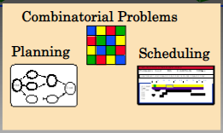

**Perception Problems**

* Perception in [Artificial Intelligence](https://intellipaat.com/blog/what-is-artificial-intelligence/) is the process of interpreting vision, sounds, smell, and touch.
* Perception helps to build machines or robots that react like humans.
* Perception is a process to interpret, acquire, select, and then organize the sensory information from the physical world to make actions like humans.
* Perception is important for creating an artificial sense of self-awareness in the robot.

**Neural Network Architectures**

* The Neural Network architecture is **made of individual units called neurons that mimic the biological behavior of the brain**.
* The input data is processed through different layers of artificial neurons stacked together to produce the desired output.
* From speech recognition and person recognition to healthcare and marketing, Neural Networks have been used in a varied set of domains.
* The Neural Network architecture is made of individual units called *neurons*that mimic the biological behavior of the brain.

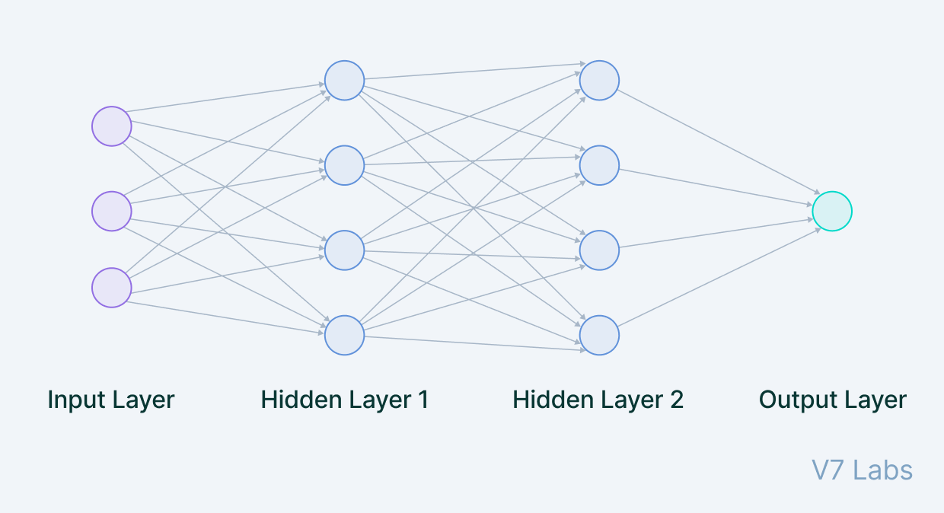

**Input Layer**

* The data that we feed to the model is loaded into the input layer from external sources like a CSV file or a web service.
* It is the only visible layer in the complete Neural Network architecture that passes the complete information from the outside world without any computation.

**Hidden Layers**

* The hidden layers are what makes deep learning what it is today. They are intermediate layers that do all the computations and extract the features from the data.
* There can be multiple interconnected hidden layers that account for searching different hidden features in the data.
* For example, in image processing, the first hidden layers are responsible for higher-level features like edges, shapes, or boundaries.
* On the other hand, the later hidden layers perform more complicated tasks like identifying complete objects (a car, a building, a person).

**Output Layer**

* The output layer takes input from preceding hidden layers and comes to a final prediction based on the model’s learnings. It is the most important layer where we get the final result.
* In the case of classification/regression models, the output layer generally has a single node. However, it is completely problem-specific and dependent on the way the model was built.

**Game Playing in Artificial Intelligence**

* Game Playing is an important domain of artificial intelligence.
* Games don’t require much knowledge; the only knowledge we need to provide is the rules, legal moves and the conditions of winning or losing the game.
* Game playing provided numerous applications that motivated the development of AI techniques, such as search and problem-solving techniques.
* In addition, it served as a popular benchmark for demonstrating progress and improvements of AI research.

**History of Game playing**

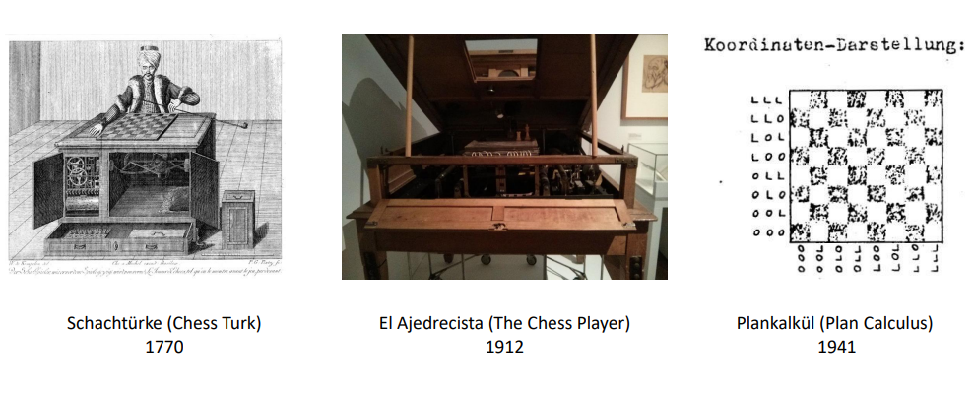

Game theory has its history from 1950, almost from the days when computers became programmable. The very first game that is been tackled in AI is chess

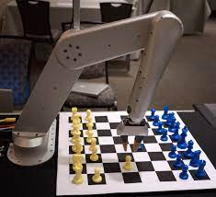

**Objectives of AI**

## **Artificial intelligence solves problems.**

## **Artificial intelligence completes multiple tasks**

## **Artificial intelligence shapes the future of every**

## **Artificial intelligence creates synergy between humans and AI**

## **Artificial intelligence is good at problem-solving**

## **Artificial intelligence helps with planning**

## **Artificial intelligence performs more complex tasks**

## 

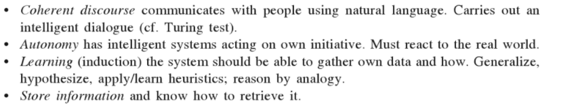

**Robotics**

* Robotics is an interdisciplinary branch of computer science and engineering.
* Robotics develops machines that can substitute for humans and replicate human actions.
* Robots can be used in many situations for many purposes, but today many are used in dangerous environments (including inspection of radioactive materials, [bomb detection](https://en.wikipedia.org/wiki/Bomb_detection) and [deactivation](https://en.wikipedia.org/wiki/Bomb_disposal)), manufacturing processes, or where humans cannot survive (e.g. in space, underwater, in high heat, and clean up and containment of hazardous materials and radiation).
* The concept of creating robots that can operate [autonomously](https://en.wikipedia.org/wiki/Autonomous_robot) dates back to [classical times](https://en.wikipedia.org/wiki/Classical_times), but research into the functionality and potential uses of robots did not grow substantially until the 20th century.
* Throughout history, it has been frequently assumed by various scholars, inventors, engineers, and technicians that robots will one day be able to mimic human behavior and manage tasks in a human-like fashion.
* Today, robotics is a rapidly growing field, as technological advances continue; researching, designing, and building new robots serve various practical purposes, whether [domestically](https://en.wikipedia.org/wiki/Domestic_robot), [commercially](https://en.wikipedia.org/wiki/Industrial_robot), or [militarily](https://en.wikipedia.org/wiki/Military_robot).

While the overall world of robotics is expanding, a robot has some consistent characteristics:

* 1.Robots all consist of some sort of mechanical construction. The mechanical aspect of a robot helps it complete tasks in the environment for which it’s designed. For example, the [Mars 2020 Rover’s wheels](https://mars.nasa.gov/mars2020/mission/rover/wheels/) are individually motorized and made of titanium tubing that help it firmly grip the harsh terrain of the red planet.
* 2.Robots need electrical components that control and power the machinery. Essentially, an electric current (a battery, for example) is needed to power a large majority of robots.
* 3.Robots contain at least some level of computer programming. Without a set of code telling it what to do, a robot would just be another piece of simple machinery. Inserting a program into a robot gives it the ability to know when and how to carry out a task.

### **What are the advantages of integrating Artificial Intelligence into robotics?**

* The major advantages of artificially intelligent robots are social care. They can guide people, especially come to aid for older people, with chatbot like social skills and advanced processors.
* Robotics also helps in Agricultural industry with the help of developing AI based robots. These robots reduce the farmer's workload.
* In Military industry, Military bots can spy through speech and vision detectors, along with saving lives by replacing infantry
* Robotics also employed in volcanoes, deep oceans, extremely cold places, or even in space where normally humans can't survive.
* Robotics is also used in medical and healthcare industry as it can also perform complex surgeries that have a higher risk of a mistake by humans, but with a pre-set of instructions and added Intelligence. AI integrated robotics could reduce the number of casualties greatly.

## Difference in Robot System and AI Programs

Here is the difference between Artificial Intelligence and Robots:

### **1. AI Programs**

Usually, we use to operate them in computer-simulated worlds.

Generally, input is given in the form of symbols and rules.

To operate this, we need general-purpose/Special-purpose computers.

### **2. Robots**

Generally, we use robots to operate in the real physical world.

Inputs are given in the form of the analogue signal or in the form of the speech waveform.

Also, to operate this, special hardware with sensors and effectors are needed.

# **Artificial Intelligence Programming**

Artificial Intelligence has become an important part of human life as we are now highly dependent on machines**. Artificial Intelligence is a very important technology to develop and build new computer programs and systems, which can be used to simulate various intelligence processes like learning, reasoning, etc.**

 one of the oldest programming languages used for Artificial Intelligence solutions. Prolog stands for "**Programming in Logic**", which was developed by French scientist Alain Colmerauer in 1970.

For AI programming in Prolog, developers need to define the rules, facts, and the end goal. After defining these three, the prolog tries to discover the connection between them. Programming in AI using Prolog is different and has several advantages and disadvantages.

Prolog may not be a great programming language to build something big, but it's a great language to study and think about problems in more logical ways rather than procedural.

Lisp has been around for a very long time and has been widely used for scientific research in the fields of natural languages, theorem proofs, and to solve artificial intelligence problems. Lisp was originally created as a practical mathematical notation for programs but eventually became a top choice of developers in the field of AI.

Although Lisp programming language is the second oldest language after Fortran, it is still being used because of its crucial features. The inventor of LISP programming was **John McCarthy**, who coined the term Artificial Intelligence.

LISP is one of the most efficient programming languages for solving specific problems. Currently, it is mainly used for machine learning and inductive logic problems.

# **Criticism of AI**

* Artificial intelligence (AI) is doing a lot of good and will continue to provide many benefits for our modern world, but along with the good, there will inevitably be negative consequences.
* The first step in being able to prepare for the [negative impacts of artificial intelligence](https://www.forbes.com/sites/bernardmarr/2018/11/19/is-artificial-intelligence-dangerous-6-ai-risks-everyone-should-know-about/) is to consider what some of those negative impacts might be. Here are some key ones:

**AI Bias:**

* chatbot that became racist. Since AI algorithms are built by humans, they can have [built-in bias](https://searchenterpriseai.techtarget.com/definition/machine-learning-bias-algorithm-bias-or-AI-bias) by those who either intentionally or inadvertently introduce them into the algorithm.
* If AI algorithms are built with a bias or the data in the training sets they are given to learn from is biassed, they will produce results that are biassed.
* This reality could lead to unintended consequences like the ones we have seen with discriminatory recruiting algorithms and Microsoft’s Twitter
* As companies build AI algorithms, they need to be developed and trained responsibly.

**Loss of Certain Jobs:**

* While many[jobs will be created by artificial intelligence](https://www.itpro.co.uk/automation/30463/gartner-by-2020-ai-will-create-more-jobs-than-it-eliminates) and many people predict a net increase in jobs or at least anticipate the [same amount will be created to replace](https://www.itpro.co.uk/automation/30463/gartner-by-2020-ai-will-create-more-jobs-than-it-eliminates) the ones that are lost thanks to AI technology, there will be jobs people do today that machines will take over.
* This will require changes to training and education programmes to prepare our future workforce as well as helping current workers transition to new positions that will utilise their unique human capabilities.

**A shift in Human Experience:**

* If AI takes over menial tasks and allows humans to significantly reduce the amount of time they need to spend at a job.
* There will likely be economic considerations as well when machines take over responsibilities that humans used to get paid to do.
* The economic benefits of increased efficiencies are pretty clear on the profit-loss statements of businesses, but the overall benefits to society and the human condition are a bit more opaque.

**Global Regulations:**

* While our world is a much smaller place than ever before because of technology, this also means that AI technology that requires new laws and regulations will need to be determined among various governments to allow safe and effective global interactions.
* Since we are no longer isolated from one another, the actions and decisions regarding artificial intelligence in one country could adversely affect others very easily.
* We are seeing this already playing out, where Europe has adopted a robust regulatory approach to ensure consent and transparency, while the US and particularly China allows its companies to apply AI much more liberally.

**Accelerated Hacking:**

* Artificial intelligence increases the speed of what can be accomplished and in many cases, it exceeds our ability as humans to follow along.
* With automation, acts such as phishing, delivery of viruses to software and taking advantage of AI systems because of the way they see the world, might be difficult for humans to uncover.

**AI Terrorism:**

* There may be new AI-enabled form of terrorism to deal with: From the expansion of autonomous drones and the introduction of robotic swarms to remote attacks or the delivery of disease through nanorobots.
* Our law enforcement and defense organizations will need to adjust to the potential threat these present.
* It will take time and extensive human reasoning to determine the best way to prepare for a future with even more artificial intelligence applications to ensure that even though there is potential for adverse impacts with its further adoption
* As is the case with any disruptive event, these aren’t easy situations to solve, but as long as we still have humans involved in determining solutions, we will be able to take advantage of the many benefits of artificial intelligence while reducing and mitigating the negative impacts.

# **Future of Artificial Intelligence**

Before going deep dive into AI in future, first, let's understand what is [Artificial Intelligence](https://www.javatpoint.com/artificial-intelligence-tutorial) and at what stage it is at present. We can define AI as, "**It is the ability of machines or computer-controlled robot to perform task that are associated with intelligence.**" So, AI is computer science, which aims to develop intelligent machines that can mimic human behaviour.

Based on capabilities, AI can be divided into three types that are:

* **Narrow AI**: It is capable of completing dedicated tasks with intelligence. The **current stage of AI is narrow AI.**
* **General AI**: Artificial General Intelligence or AGI defines the machines that can show human intelligence.
* **Super AI**: Super AI refers to self-aware AI with cognitive abilities that surpass that of humans. It is a level where machines can do any task that a human can do with cognitive properties.

**At the current stage, AI is known as Narrow AI or Weak AI, which can only perform dedicated tasks**. For example, **self-driving cars, speech recognition, etc.**

## Future impact of AI in different sectors

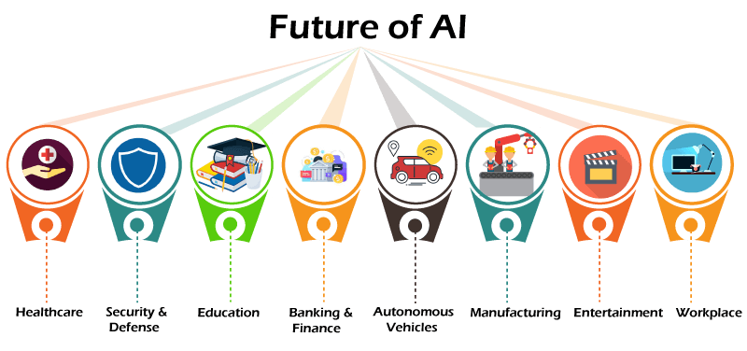

### **Healthcare:**

AI will play a vital role in the healthcare sector for diagnosing diseases quickly and more accurately. New drug discovery will be faster and cost-effective with the help of AI. It will also enhance the patient engagement in their care and also make **ease appointment scheduling, bill paying**, with fewer errors

### **Transportation:**

The fully autonomous vehicle is not yet developed in the transportation sector, but researchers are reaching in this field. AI and machine learning are being applied in the cockpit to help reduce workload, handle pilot stress and fatigue, and improve on-time performance. There are several challenges to the adoption of AI in transportation, especially in areas of public transportation. There's a great risk of over-dependence on automatic and autonomous systems.

### **E-commerce:**

Artificial Intelligence will play a vital role in the e-commerce sector shortly.

It will positively impact each aspect of the e-commerce sector, ranging from user experience to marketing and distribution of products. We can expect e-commerce with automated warehouse and inventory, shopper personalization, and the use of chatbots in future.

**AI Workforce Augmentation**

* the future, we’ll see even more of our jobs being outsourced to AI. Artificial intelligence can now do amazing things like read, write, speak, and smell that previously only humans could do.
* That frees up humans to do the things we do best on the jobs, like being creative and practicing emotional intelligence**.**

**Better Language Modeling Capability**

* Language modeling is the process that allows machines to understand and communicate with us in ways we understand. We can even use it to take natural human language and turn it into computer code that can run programs and applications.
* Recently, we have seen the release of GPT-3 by OpenAI, the most advanced and largest language model ever created, consisting of around 175 billion parameters for processing language.
* OpenAI is already working on its successor, GPT-4, which will be even more powerful. Although the details haven't been confirmed, some people believe it will contain up to 100 trillion parameters, making it 500 times larger than GPT-3.
* In theory, that would take it one giant step closer to being able to create language and hold conversations that are indistinguishable from those of a human. This model will also become much better at creating computer code.

**Cybersecurity**

* This year, the World Economic Forum noted that cybercrime may actually pose a more significant risk to society than terrorism. As machines take over more of our lives, hacking and cybercrime inevitably become bigger and more dangerous problems.
* The good news is that artificial intelligence can be a helpful weapon against cybercrime, because AI is quite good at analyzing network traffic and recognizing patterns.

**The Metaverse**

* The word “[metaverse](https://bernardmarr.com/what-is-the-metaverse-an-easy-explanation-for-anyone/)” describes a unified, persistent, digital environment where users can work and play together. It's a virtual world like the internet, but with the emphasis on enabling immersive experiences that are created or enabled by users.
* Companies like Meta, Microsoft, and Epic Games are helping to build the metaverse, and AI will be a key component of creating online immersive environments where humans can feel at home and explore their creative impulses.

**Low-Code or No-Code AI**

* In the not-so-distant past, you needed specialized coding skills to create even simple websites. But these days, we have drag-and-drop graphical interfaces that make it easy to create websites and post new content with just a few clicks.
* In the future, the same thing will happen with artificial intelligence and machine learning. We will have simple tools we can use to build our AI so we are less reliant on coding skills and can still use AI to develop more and more applications.

**. Data-Centric AI**

* Traditionally, artificial intelligence has relied on big data. We needed huge volumes of data to train the AI's algorithms and neural networks, so they were software-centric.
* The latest trend is becoming more focused on the data, because many applications beyond the world of big tech have access to billions of unique, structured data sets.
* For those companies to use AI, they need to rely on high-quality data, and they will need domain expertise from people to help label the data. With that data, they can use AI and machine learning to develop better technologies.

**Autonomous Cars**

* Tesla says its cars will demonstrate full self-driving capability by 2022. Its competitors – which include Google, Apple, General Motors, and Ford – are all expected to announce major leaps forward in the autonomous car space in the next year.
* In the year 2022, we will also likely see the first autonomous ship crossing the Atlantic from the U.K. to the U.S.

**Creative AI**

* Creativity is often seen as strictly a human skill. But now, artificial intelligence can pull off creative tasks, including designing logos, songwriting, creating infographics, and writing blog posts.
* The creative side of AI will simply explode over the coming years as we see new capabilities emerging.

Apart from above sectors, AI has great future in manufacturing, finance & banking, entertainment, etc.